Children and Their Safety are Important at Chestnut Hill UMC
We rejoice that as a church we are able to offer carefully planned, age appropriate care and activities for our children and youth.
Today, children ages 6 and above will stay in the sanctuary for worship.
The Nursery for infants up to age 6 is located in Classroom 101 (exit through the right side door at the front of the sanctuary, pass through “the Commons,” go through the double doors to the Education Building and follow the hallway to the
Nursery at the end of the hall on the left).

DIRECTORY OF CHESTNUT HILL UNITED METHODIST CHURCH
 | Sharma Lewis | Richmond Area Resident Bishop
 | Scott Davis | Lynchburg District Superintendent
 | Liz Ecklund | Minister
 | Monica Campbell | Administrative Assistant
 | Heather Wilson | Director of Music Ministry
 | Judy Martin | Bookkeeper
 | Judy Robertson | Lay Leader


Chestnut Hill
United Methodist Church

Making disciples of Jesus Christ
for the transformation of the world.
You are welcome at Chestnut Hill UMC.

4660 Fort Avenue ~ Lynchburg, Virginia 24502
Church: 434-239-8423
Pastor’s Cell: 434-258-2934; Pastor’s Home: 434-319-5646
Email Pastor Liz: Pastorliz@aol.com
chestnuthillumc@comcast.net ~ on the web at chestnuthillumc.net
Find us on Facebook: Chestnut Hill United Methodist Church

Chestnut Hill United Methodist Church
10:30 a.m. ~ June 27, 2021 ~ 5th Sunday after Pentecost
Our ministry vision for the Virginia Annual Conference is “to be disciples of Jesus Christ who are lifelong learners, who influence others to serve.”
Welcome! Join us in worshiping God!
Welcome and Ministry Announcements
Welcome in the name of Christ our Lord.
Thank you for silencing cell phones as we gather to worship God.
Invocation
Prelude “’Tis So Sweet To Trust in Jesus”
Call to Worship
Let us gather this day in worship and let Christ's love be seen in us!
The way of the world is to care for oneself and one's own interests.
But in Christ we are called to care and provide for the needs of others.
Working together, God's people can touch many by sharing God's mercy.
Then let our voices be in praise as we share God's blessings with others.
Blessed be the name of the Lord!
*Singing Our Faith # 117 “O God, Our Help in Ages Past”
Morning Prayer
O God, in Your wisdom You have shown us that if we would save ourselves, we must be willing to lose ourselves. And if we would know Your blessings, we must be willing to share them. Use us, Lord. In Christ we pray. Amen
Prayer for Illumination Linda Jessen
Lord, open our hearts and minds by the power of your Holy Spirit, that, as the Scriptures are read and your Word proclaimed, we may hear with joy what you say to us today. Amen

Gospel Lesson Mark 5:21-43 (MSG) Linda Jessen
The Word of God for the people of God.
Thanks be to God.
Singing Our Faith # 474 “Precious Lord, Take My Hand”
The Good News “Healing Power of Jesus”
Special Music “He Hideth My Soul”
The Prayers of the People
The Lord’s Prayer
Our Father, who art in heaven, hallowed be thy name. Thy kingdom come,
Thy will be done on earth as it is in heaven. Give us this day our daily bread and forgive us our trespasses, as we forgive those who trespass against us. And lead us not into temptation, but deliver us from evil. For thine is the kingdom, and the power, and the glory, forever. Amen.
*Singing Our Faith #367 “He Touched Me”
*Blessing and Dismissal
*Postlude

Scatter to Serve God & Neighbor
Welcome to all! We gather to praise God for the innumerable blessings given
to us and to grow deeper in the Spirit. Joyfully, let us lift our hearts to God.

**This Week’s Calendar**
Sunday, 6/27 | 11:30 a.m. | Reception for Pastor Liz  Be sure to join us after worship in the Fellowship Hall for a Farewell Reception for Pastor Liz.
Wednesday, 6/30 | 1:00 p.m. | Administrative Council meeting

In Memoriam
Helen H. Camden
June 26, 1928 - May 9, 2021
Chestnut Hill United Methodist Church extends Christian love and sympathy to the family of Helen Camden.
**Sunday School books, for the summer quarter, have been placed in the Commons for anyone who would like a copy. Sunday School will resume in September.
In the Grocery Cart This Month:
For JUNE/JULY/AUGUST:
Snack foods : Granola Bars, Breakfast Bars, packs of crackers, snack size bags of chips, fruit cups, and Applesauce cups.
Other Needs: Laundry detergent, dish liquid, multi-surface cleaner, paper towels, toilet paper, baby wipes, diapers sizes 5 & 6, body wash, shampoo & conditioner, and razors.
Place donations in the grocery cart, located in the Commons.
**NOTE: Please put all liquids in the box provided. Tape down all flip top bottles. AND no “baked goods” of any kind.

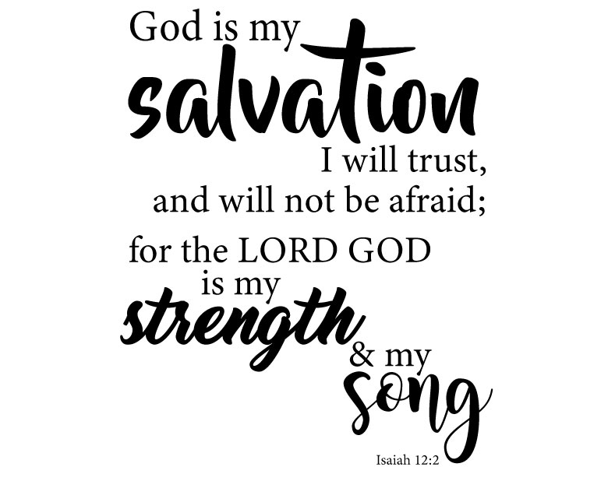

**This Week’s Calendar**
Sunday, 6/27 | 11:30 a.m. | Reception for Pastor Liz  Be sure to join us after worship in the Fellowship Hall for a Farewell Reception for Pastor Liz.
Wednesday, 6/30 | 1:00 p.m. | Administrative Council meeting
In Memoriam
Helen H. Camden
June 26, 1928 - May 9, 2021
Chestnut Hill United Methodist Church extends Christian love and sympathy to the family of Helen Camden.
**Sunday School books, for the summer quarter, have been placed in the Commons for anyone who would like a copy. Sunday School will resume in September.
In the Grocery Cart This Month:
For JUNE/JULY/AUGUST:
Snack foods : Granola Bars, Breakfast Bars, packs of crackers, snack size bags of chips, fruit cups, and Applesauce cups.
Other Needs: Laundry detergent, dish liquid, multi-surface cleaner, paper towels, toilet paper, baby wipes, diapers sizes 5 & 6, body wash, shampoo & conditioner, and razors.
Place donations in the grocery cart, located in the Commons.
**NOTE: Please put all liquids in the box provided. Tape down all flip top bottles. AND no “baked goods” of any kind.

